Getting Reagents Ready
- Make DNA/RNA wash from concentrated Wash1 and Wash 2 mixes.
  - We add 20 ml of isopropanol directly into wash 1
  - We add 30 ml of isopropanol directly into wash 2
- Mix DNA/RNA shield with equal amount of nuclease free water (usually 25 ml with 25 ml)
- Reconstitute Proteinase K with 1 ml of proteinase K storage buffer (must use soon after)
- We do not use Dnase 1
Reagent Locations
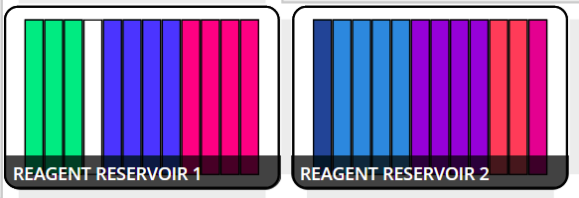
Location | Reagent
*Green on far left A1-A3 | Mix of beads and ethanol
*Blue in Res1 A5-A8 | MagBead DNA/RNA Wash1
*Magenta in Res1 A9-A12 | MagBead DNA/RNA Wash2
Dark Blue in Res2 A1 | Dnase 1 (Do not Use)
Light Blue in Res2 A2-5 | STOP (I don't think this is anything)
*Purple in Res2 A6-A9 | Ethanol 95%
*Orange in Res2 A10-A11 | Ethanol 95%
*Pink in Res2 A12 | DNA/RNA free water

Sample Prep
1. cut .5 of an inch from bottom of a tiller and cut make many cuts equaling around 1 inch into a tube. Do this three times per sample. (Kit calls for only 5mg of plant sample. This probably will not work to get epichloe though, our last kit called for 50mg but we did this anyways and it would literally not work at 50 mg of sample.)
2. Add 800 ul of DNA/RNA Shield to sample and put in Genogrinder for 1 min
3. Add 10 ul of Proteinase K, mix then incubate at room temp for 30 min
4. Centrifuge at 10,000g for 30 seconds, transfer 200ul of supernatant into a new tube. (Maybe 500ul if possible just in case we need to do samples over again.)
5. Create data table corresponding to sample locations on a 96 well plate. Transfer 200ul of sample to 2ml deep well plate. Once 2ml deep well plate is full of samples transfer to magnetic module.

Protocol
1. When protocol starts the temp module will cool itself to 4 degrees.
2. It will then mix the beads by aspirating and dispensing many times
3. When all beads are transferred into wells it will pause so you can mix beads on a shaker for 10 min.
4. Place 2ml deep well plate back onto magnetic module and it will engage for 7 minutes to pellet the beads
5. The machine will then aspirate the supernatant and put it into the waste container
6. DNA/RNA wash 1 will then be added to beads then beads will be violently mixed
7. Beads will pellet for 7 minutes and supernatant will be discarded
8. DNA/RNA wash 2 will be added to beads and machine will mix the beads somewhat violently again.
9. Beads will pellet for 7 minutes and supernatant will be discarded
10. 1st set of ethanol 95% will be placed into beads and will be violently mixed
11. Beads will pellet for 7 minutes and supernatant will be discarded
11. 2nd set of ethanol 95% will be placed into beads and violently mixed
12. Beads will pellet for 7 minutes and supernatant will be discarded
13. A 10 min delay will happen to allow beads to dry
14. Adds water to beads 50 ul and mixes violently
15. Beads will pellet for 7 minutes
16. The supernatant will be aspirated and transferred to the 100 ul well plate.
17. The end result will be 50 ul of pure DNA inside the 100 ul plate on the temp module.

